1.1

|  |  |  |  |
| --- | --- | --- | --- |
| № | Auto Trace Configuration Options | Expected Results | Description |
| 1 | on | Query result and trace result | Autotrace is enabled |
| 2 | off | Query result | Autotrace is disabled |
| 3 | traceonly | Trace result | Autotrace without query result |
| 4 | Explain | Only explain plan | -//- |
| 5 | statistics | Only statistics | -//- |
| 6 | Explain statistics | Statisctics and explain plan | -//- |

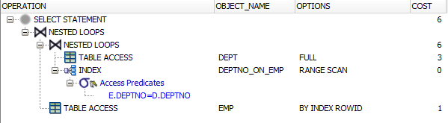

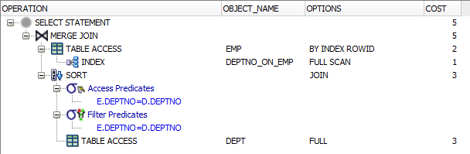

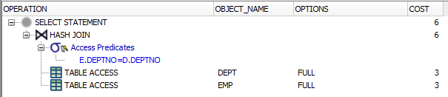

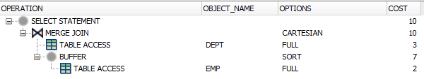

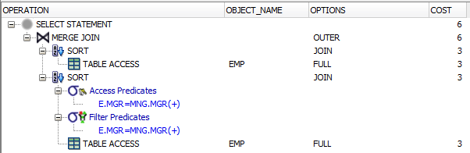

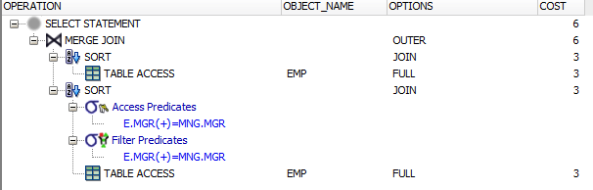

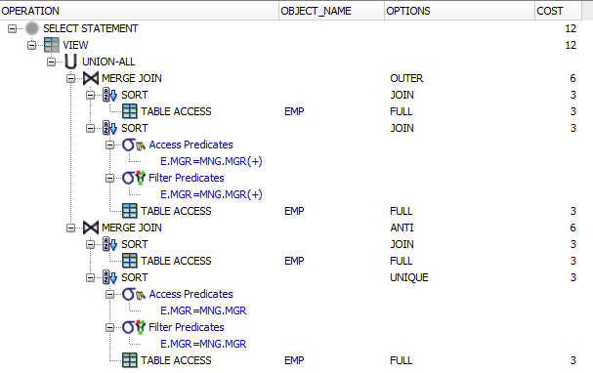

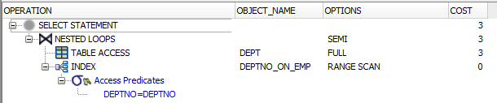

Used table:

select * from scott.dept dept

where exists

( select /*+NL_SJ*/ * from scott.emp emp

where emp.deptno = scott.dept.deptno

);

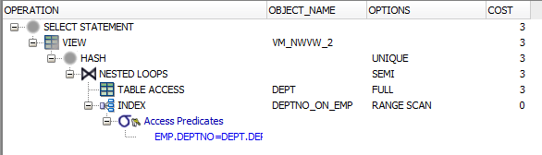

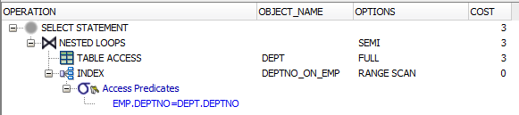

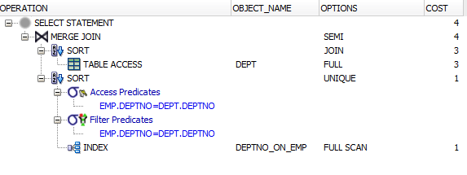

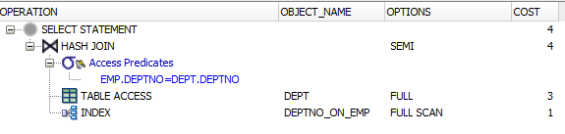

Used table:

select * from scott.dept dept

where not exists

(

select * from scott.emp emp

where emp.deptno = scott.dept.deptno

);

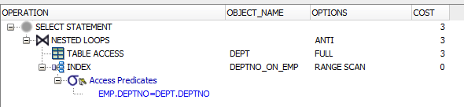

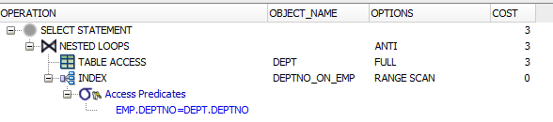

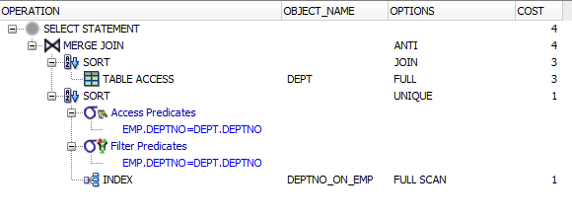 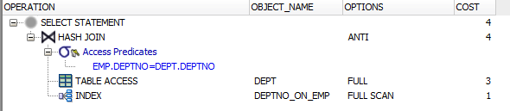

**Explain plan cost values.**

Used tables:

create table big_table as

select rownum as key, value from(

select round(dbms_random.value(1, 10000)) as value

from dual

connect by level <= 100000

);

create table small_table as

select rownum as key, value from(

select round(dbms_random.value(1, 100)) as value

from dual

connect by level <= 100);

Used indexes:

create index st_idx on small_table (key);

create index bt_idx on big_table (key);

|  |  |  |  |  |  |  |
| --- | --- | --- | --- | --- | --- | --- |
| Join Access “A” | Join Access “B” | Nested Loop | Hash Join | Sort-Merge Join | Anti-Join | Semi-Join |
| Small table | Small table | 113 | 6 | 6 | 6 | 6 |
| Small table | Big table | 5626 | 61 | 443 | 61 | 61 |
| Big table | Big table | 5622554 | 317 | 880 | 297 | 297 |
| Small table | Indexed big table | 203 | 61 | 420 | 61 | 61 |
| Indexed small | Indexed big | 162 | 61 | 420 | 61 | 61 |
| Indexed big | Indexed big | 200122 | 317 | 857 | 297 | 297 |
| Indexed small | Big | 162 | 61 | 442 | 61 | 61 |
| Indexed small | Indexed Small | 103 | 6 | 5 | 3 | 3 |